“Lab 2 - Blexbolex Style Exploring Scaling via Variables” by Zoë Wood is licensed under CC BY-NC-SA. Accessed from www.engage-csedu.org.

. |  | .
Fall 2015  . | Computational Art | Zo¨e Wood  .

Lab 2 Composition - Blexbolex - part 1

Goals

The goals for this lab are:

  - Use a variable to control scale and position of a sketch component
  - Alter and explore the role of scale in a sketch’s composition
  - Practice using transforms ( translate and scale) in a sketch to con- trol scale of a portion of your design
  - Apply your knowledge of the 2D coordinate system in order to appro- priately scale and translate a portion of your design
  - Study the composition and coloring used by the artist, Blexbolex
  - Copying composition and color to practice design

Modality

Individual

Overview

One of the challenges with using Processing to produce visual art is that the ‘look’ is very clean and digital. Some artists intentionally use this style to create compelling and nostalgic art in a comic book style. Blexbolex is a French comics and illustrator who design work with simple shapes and colors translates well into a Processing sketch. Blexbolex’s use of composition (i.e. the scale and positioning of his shapes/characters) contributes strongly to the overall ‘feeling’ and ‘story’ of his work. See Figure 1 for an example.
Today we will be re-creating and then re-mixing a Blexbolex design in order to play with composition and scale.

1

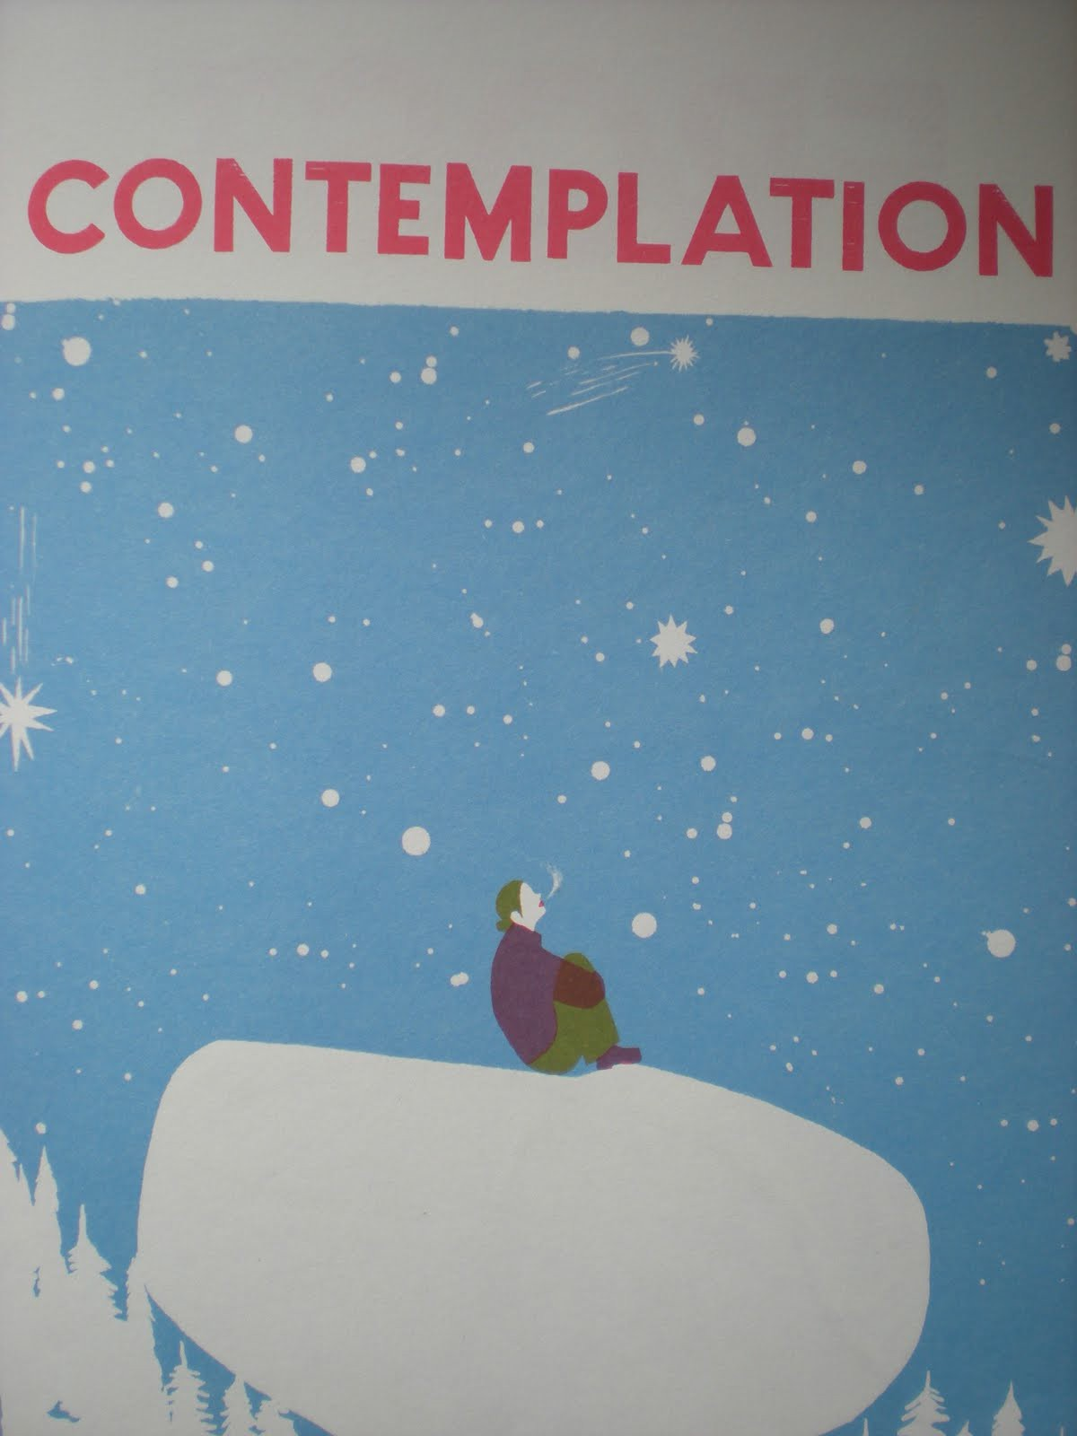

Figure 1: One of Blexbolex prints (contemplation). Consider how the scale and positioning of the individual and their attention (focus) creates or adds to the mood of this image.

Details

Task: You must create an image using Processing of a scene that explores composition to convey story or mood and the use of variables in programming. Your ‘sketch’ of the scene must:

- approximate an established design by the artist Blexbolex
- be at least 400 x 400
- include the use of at least three variables to represent scale, translation in x and translation in y
- apply translation and scale in order to ‘play’ with the composition of your sketch via only modifying the scale of one aspect of the design
- be in color - if you modify the colors from the original print, please explain why

In order to accomplish this:

- first identify the Blexbolex sketch you’d like to copy - it must be com- posed of multiple elements (ie not just one character) because you will be modifying the sketch by altering the scale of one component of the design (see the example in Figure 2, where the scale of the diver has been altered in several sketches). You must get instructor approval for the sketch you select.
- next you will need to identify the character or sketch component (ie tree etc.) that you wish to ‘play’ with its composition - think about how the image will change when a given component is moved or resized.

- next re-create the Blexbolex sketch as closely as possible in Processing and save an image of the correctly scaled sketch, however, encapsulate the portion of the sketch that you will re-scale in a pushMatrix and popMatrix with variables for the scale and translation that are set to not change the image.
- Next, produce three different output images of your sketch via chang- ing the values of your transform variables (be prepared to demo chang- ing a variables value and showing the correctly transformed portion of the sketch).

You can create your own unique design in a Blexbolex style with permission of the instructor (design sketch must be provided).

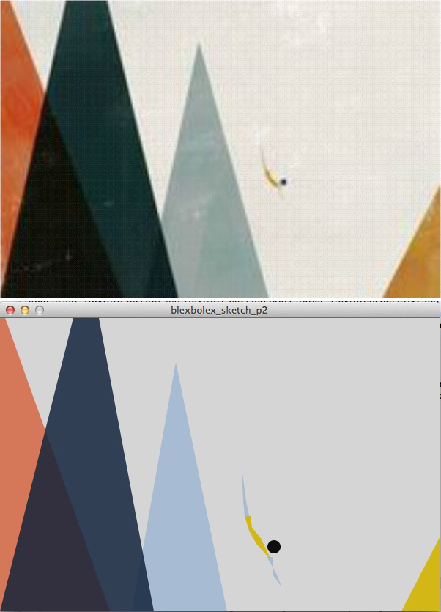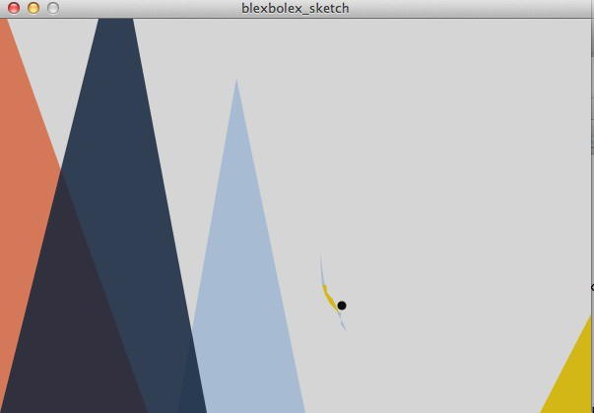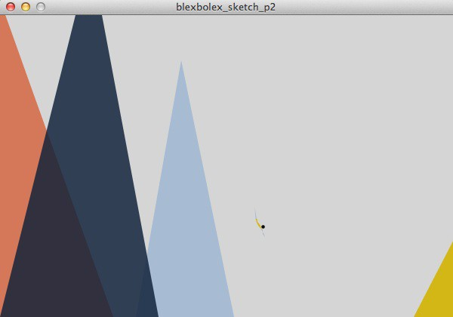

Figure 2: Top right is another Blexbolex and on the left is the matching Processing sketch example (trying to match scale). Again consider how the scale and placement of the human character creates a specific mood and focus. In the second row, the diver is re-sized to be twice as large (left) and half the size (right) - notice how the re-sizing changes the story and feel of the image.

Demo:

In order to receive credit for this lab, you must demo your sketch to your instructor or TA. For every lab, your score will be broken down 75% for meeting the technical requirements and 25% for aesthetics. This means that your sketch will be graded on how it looks - this grade is predominantly decided based on effort - i.e. did you attempt to make a visually pleasing sketch that fits the specifications or did you do the bare minimum?

Submitting your sketch

You must post an image of your sketch to your pinterest Computational Art board also pin your reference Blexbolex.

Resources

pushMatrix(); popMatrix();
{rotate(radians); translate(tx, ty);
radians(degress) - converts from degrees to radins. e.g. : rotate(radians(90));

//Example program for transforms - ALWAYS model at the origin! - Z. Wood size(600, 600);
background(128);

fill(46, 130, 229);
//dragonfly modeled at the origin - i.e. centered around (0, 0)
//then drawn at the center pushMatrix(); translate(300, 300);
ellipse(0, 0, 50, 400);
ellipse(0, -225, 50, 50);
//wings
ellipse(175, -100, 300, 50);
ellipse(175, -150, 300, 50);
//wings
ellipse(-175, -100, 300, 50);
ellipse(-175, -150, 300, 50);
popMatrix();

//the same dragonfly, now scaled and rotated pushMatrix();
translate(450, 450); rotate(PI/4); scale(0.5);
ellipse(0, 0, 50, 400);
ellipse(0, -225, 50, 50);
//wings
ellipse(175, -100, 300, 50);
ellipse(175, -150, 300, 50);
//wings
ellipse(-175, -100, 300, 50);
ellipse(-175, -150, 300, 50);
popMatrix();

