CSCEXX Exercise X: Marble Maze I
“Marble Maze I by Leen-Kiat Soh and Elizabeth Ingraman is licensed under CC BY-NC-SA. Accessed from www.engage-csedu.org.

Assigned: X
Due: Part 1: X; Part 2: X

Objectives
The objectives of this exercise:
- Computational:
  - Decomposition: dividing a marble maze into individual segments and working on the requirements of each segment separately (height, length, time, materials).
  - Abstraction: focusing on multiple uses of individual materials, instead of just the material itself (e.g., using string to hold different pieces together); fitting individual segments together based on their start and end points rather than looking at the entire segment; considering the overall goal and how it affects the design
  - Generalization: looking at similarities and differences among the individual segments when deciding how to best fit them together to form a larger maze.
  - Evaluation: determining if the structure of the individual segments meets the requirements (height, length, time, materials, etc); (b) determining the best order in which to fit the segments together and whether any segments need to be altered before being combined into a larger maze; determining if the final combined maze meets the requirements (height, length, time, materials, etc).
  - Learning how to collaborate on developing complex programs, algorithms, or software solutions by designing the marble maze as a team and separately building the maze segments.
  - Learning how to utilize the restrictions of an abstract programming interface (API)—important in using standard libraries and programmer-defined modules—by developing maze segments using a fixed list of materials.
  - Learning about the need to design subroutines or functions (or modules) with clear inputs and outputs—important in software modularity and reusability—
by making sure that the segments fit together.
  - Developing testing and debugging skills when the marble gets stuck and cannot move on to the next segment.
- Creative:
  - Surrounding: using your senses of sight, touch and sound to help you design and construct a maze for a marble.
  - Capturing: documenting the height and length of a marble maze, calculating its path and measuring its performance.
  - Challenging: using limited materials and devising new methods of fastening to build a segment of a marble maze through which a marble can travel without stopping.
  - Broadening: acquiring new skills in testing and collaborating by connecting individual segments into a functioning maze which meets operational parameters.
- Collaborative:
  - Being open to all points of view and resolving group conflicts in a constructive way.
  - Giving and receiving thoughtful and constructive feedback in order to develop your group project.
  - Meeting group deadlines, including completing your individual work in a timely manner.
  - Contributing substantively to the group process, using your skills, knowledge and experience. Working together as a team to achieve a common goal; being able to both compete against and cooperate with other teams.

Problem Description
Using ONLY the specified materials, you will be making a maze through which a marble will travel.
The completed maze must have an intentional path, along which a marble can travel without stopping, and with a clear beginning and ending point. This path can include loops.
You may start the marble’s journey through the maze by dropping it. The marble may not travel on the floor more than 4 inches. The marble must travel from a minimum height of 12 inches and must travel a minimum of 4 linear feet (in any configuration) and must reach the end of the maze without stopping. Any pathway for the marble must be elevated at least 4” off the floor. The marble should take at least 4 seconds to complete its travel from beginning to end. The group building the maze with the longest marble travel time will receive bonus points.
In Part 1 each member of your group will construct a 12” (minimum) segment of maze which a marble can travel along or through without stopping. In Part 2, you will have to integrate your segment of maze with those of your other group members.
Each group will set up a wiki page on agora.unl.edu. The name of this page should be: “Marble Maze I by <Course> Group <Name>” where <Course> is the course abbreviation and <Name> is your group name (e.g., Marble Maze I by CSCE XXX Group Awesome).
Any member may create the group page. Note that there should be only one page created per group. Before you create a new page, make sure that one doesn’t already exist.

1. Part One [20 points]

1.1. Develop and Test Individual Segments
In Part 1, group members will construct separate segments of the maze using the specified materials.
The ability to collaborate on complex programs is extremely important in computer science. Programmers almost never work by themselves on code that is intended to operate standalone. From software giants such as Microsoft to small game development studios, programmers must be able to collaborate while writing new modules for the same program in parallel. Such collaboration is further complicated when the new code must interface with legacy code written by a programmer who no longer works at the same company. Poor collaboration amongst programmers can result in numerous bugs, missed shipping dates, and even bankruptcy for the company. Creative thinking skills assist in identifying and resolving problems between new modules and legacy code thereby promoting more effective collaboration between programmers.

As inspiration, watch this short excerpt on YouTube from “The Way Things Go,” a movie about a Rube Goldberg-type of (almost) perpetual motion machine, in which individual components combine to allow motion along a complex path.
https://www.youtube.com/watch?v=GXrRC3pfLnE
You may also wish to look up YouTube videos using the search terms: cardboard marble run.
To construct your maze, you may use ONLY these materials:
- Any paper (e.g., newspaper, sheets from workbook, printer paper) or cardboard. No piece may be larger than 4” in its longest dimension
- Regular paper clips. Paper clips must be transformed (cut, bent, etc.) from their default shape.
- String (e.g., sewing threads, shoe strings)
- A marble. Marbles are supplied.
You may not use glue, tape or staples.
Note: You may not use stairs, walls, ceilings or other found conditions to elevate your maze. These are “other materials.”
Constraints can force creativity. Material constraints force you to “think materially,” looking at familiar materials in new ways and getting ideas from manipulating them. Discovering (through testing) what a material can and cannot do, failing and trying again, and grappling with real world constraints such as weight, gravity and friction can lead to innovative engineering. At the same time, thinking metaphorically, and considering a wide variety of things that roll, drop, meander or travel can lead you to unexpected sources of inspiration. This exercise also forces you to work with what you have and to “do a lot with a little.” The ability to do more with less and to make creative use of existing resources is a valuable skill in the contemporary workplace.

IMPORTANT: Each group member must construct a separate segment of the maze that meets the following requirements: (1) Each maze segment must be at least 12” in linear length with clearly defined beginning and ending points. (2) The marble should take at least 1 second to travel from the beginning point to the ending point. Marbles will be supplied to groups at the start of Part 1 so you can test the second requirement.
The use of clearly defined beginning and ending points for modules is very important in computer science. These beginning and ending points work as an instruction manual for an existing module so that a programmer knows what to expect from the module. In this way, a programmer can utilize an existing module without having to understand every line of source code in that module. This is critically important since the source code is often unavailable and even when it is, understanding it line-by-line would take a prohibitively large amount of time and money. (Imagine reading all 1.7 million lines of code in the F-22 Raptor jet fighter.) However, a set of ambiguous instructions, such as using variables x and y, is nearly as useless as no instructions at all. On the other hand, for real-world abstract programming interfaces, programmers do not have the space to provide exhaustive instructions on how every module works. Instead, programmers must think creatively about how to succinctly describe the beginning and ending points for their modules.

Remember that these are only the minimum requirements. You are encouraged to go beyond these requirements since bonus points will be given to the group with the longest marble travel time.
NOTE: You will be using these segments over time to complete the rest of this exercise. Individual segments should be robust enough that they can withstand multiple traversals by the marble.
After the individual segment is completed and tested, each group member should upload a video of their segment to YouTube and post the link to that video on your group’s wiki page. Be sure to set your YouTube video as Public and to include your name when you post the link on the wiki page.
NOTE: The points for Part 1 are based on individual completion of the segments meaning that if one group member fails to complete their segment, then only they will lose points. Individual group members will also lose points if their segment does not meet the individual requirements.

2. Part Two

2.1. Integrating Individual Segments into a Single Maze [20 points]
In Part 2 group members need to combine the separate segments they have constructed and tested into a combined maze.
IMPORTANT: The connection methods must meet the following two requirements: (1) The connections should allow the marble to traverse the entire maze on an uninterrupted path without stopping. (2) The connection methods must be reversible, meaning that it is possible to separate the single maze back into segments. Appendix A has examples of possible connections.
Developing testing and debugging skills is vitally important in computer science. Real-world software applications are massive in scope and may involve millions of lines of code. These applications are so large it is inconceivable for a single programmer to have read all the lines of code and so large groups of programmers must work together collaboratively. In such an environment, mistakes are bound to be made when programmers work with unfamiliar code. Furthermore, a complex application may change constantly during development with new features added and old features modified or removed. Obviously, programmers cannot go back through the source code line-by-line after every feature change to make sure that all potential bugs have been removed. Instead, the programmers (and quality assurance staff) are constantly testing and debugging use cases for the application until (and often after) it ships. The quality of these use cases and thus, the number of bugs removed and quality of the final application, depends directly on the creative thinking skills of those testing and debugging the application. Note also that testing and debugging are not limited to software engineering or computer science. These are skills important in various disciplines involving, for example, evaluation and refinement of a process or methodology, a product design or an experiment setup.

Group members will likely need to resolve problems that occur in the connections between different segments. These connections may even require a partial redesign to one or more segments. Group members should make note of the connection methods used and any design changes since these will be needed to answer the questions in Section 2.2.
NOTE: In the event that one segment is missing, group members do not need to include it in the combined maze. If the segment is incomplete, it is the responsibility of the individual group member to finish the segment and make the connection on their own.
After testing, your group should take a video of the completed maze in operation and upload that video to YouTube. Make sure your video is set to Public and post a link to your video on your group’s wiki page, along with the total travel time of your completed maze.
IMPORTANT: The entire maze must meet the requirements given in the Problem Description regarding minimum starting height and length and duration of travel for the marble.
There will be bonus points awarded to the group whose maze has the longest travel time.
NOTE: The points for Part 2 are based on whether the connections and combined maze meet the requirements so all group members are penalized when requirements are not met.

2.2. Analysis and Reflection [20 Points]
Post your Analysis and Reflection responses in the Discussion area of your page, NOT in the body of the page.
You are expected to discuss these analysis and reflection questions among your group. One member must start a new topic for EACH Analysis or Reflection by selecting “New Comment.” In the Topic area, type “Analysis” or “Reflection” and in the Comment area, paste in the Analysis or Reflection questions. Using the Analysis or Reflection questions as prompts, each member will post their responses as a reply to the original comment. This process will keep the group’s Analysis and Reflection in separate threads and make it easier to follow the development of your answers.
You will be graded individually based upon your contributions to the group Analysis or Reflection. In order to receive individual credit for Week 2, each group member must contribute to the answers to these questions. Group members who do not contribute to the Analysis or Reflection Discussion will not receive points.
Analysis [10 points]. Respond to these questions: (1) How did your testing go for both your individual unit and the integrated maze? What changes did you have to make after integration testing to fix individual units? (2) What do you think is key to the success or failure of your design? Be specific about what aspects worked well and what aspects need work.
Reflection [10 points]. Respond to these questions: (1) How did the group distribute its work of making and combining the maze modules? Did your planning work well? What would you do differently? (2) Did your group have to redesign segments in order to meet the testing requirements? If yes, identify the reasons for why the initial designs failed; if no, identify the reasons why the initial designs succeeded. What considerations were (or should have been) considered during the initial designs in order to meet the testing requirements?

Deadlines and Hand-In
Part 1 Deadline – [XX, 11:59 p.m.]: Individual maze segments: You must have completed making your individual maze segment and have posted a link to a YouTube video of the operation of your individual segment on your new group’s wiki page. Be sure to include the total travel time of your maze.
Part 2 Deadline – [XX, 11:59 p.m.]: Your group’s Analysis and Reflection are due. Your individual Analysis and Reflection comments must be posted in the Discussion area of your new group page.

Grading
Combined maze: graded as a group; 5 point penalties for failing to meet maze requirements or for travel time < 4 seconds. 10 point bonus to the group with the longest travel time.
Analysis and Reflection: graded individually. Each member must post in the Discussion with a minimum of 3-5 coherent, relevant sentences for full credit.
Late work will not be graded.

Appendix A. Examples of Connections for Part Two
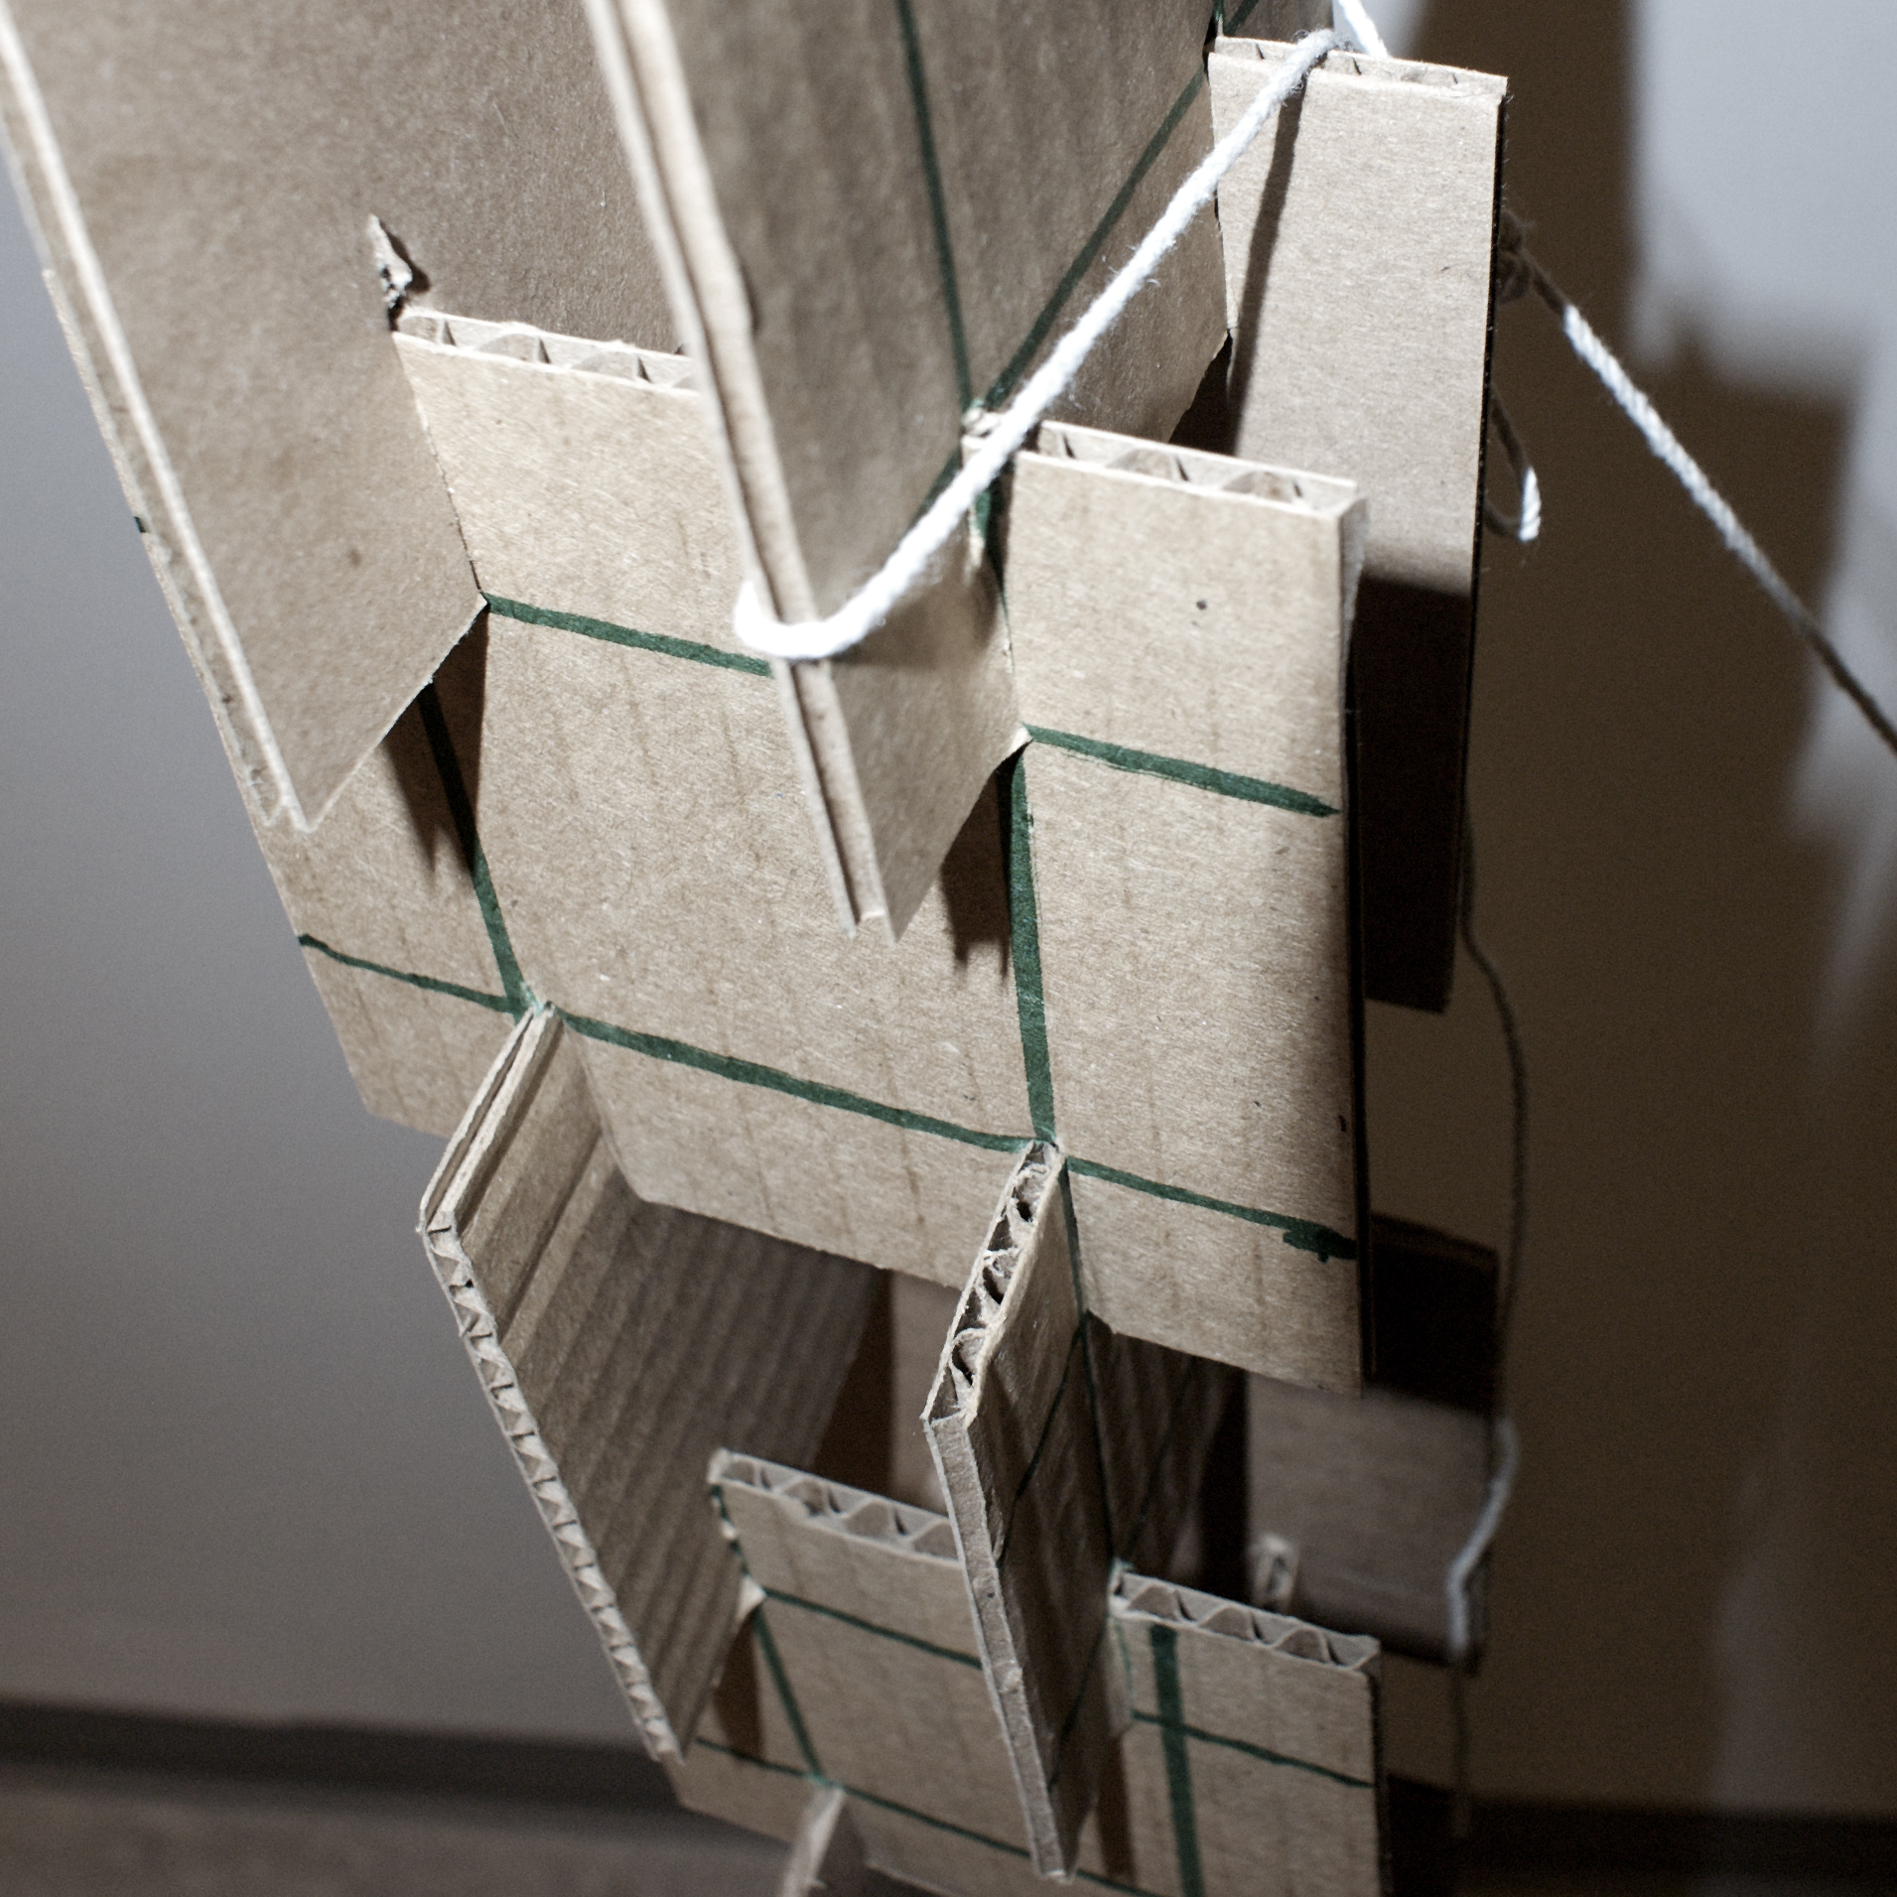 | 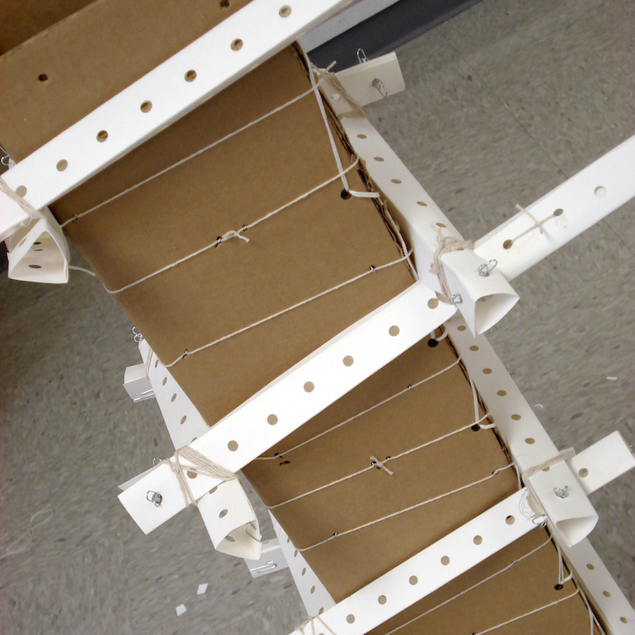 | 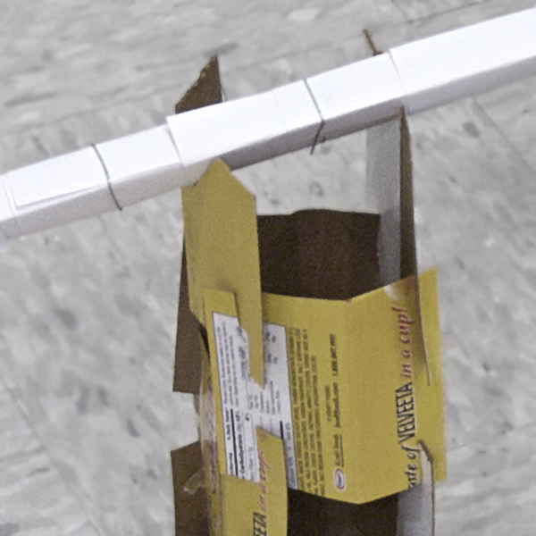

END OF EXERCISE

