Lottery and the Wealth Gap
By Kaitlyn Zeichick, Stephanie Lin, and Colleen Lewis
Acknowledgements: Justin Allman, Fiona Callahan, Henry Sojico
Summary | This assignment demonstrates how the lottery contributes to a growing wealth disparity by redistributing money from low income families to middle and high income students in the form of scholarships. Students will create a simulation based on a real Georgia lottery game to learn about the mechanisms that cause the wealth gap to widen. This assignment is based on a math assignment by Justin Allman.
Topics | Practice with lists, loops, and random number generators.
Audience | CS1
Strengths | Explores important current issues and provides practice with lists.
Weaknesses | The use of random numbers in the assignment makes it difficult to test; this may require instructors to manually oversee student results or help students write primitive test cases.
Dependencies | Assumes that students have already learned about lists, loops, and functions.
Difficulty | This should be an intermediate assignment.
Variants | Adding or removing starter code, helper functions, and guiding comments could significantly affect the difficulty of the assignment. Instructors may choose to have students write the scatterplot code themselves.

Objective
Students will model a real-world problem using lists, loops, and random number generators in Python.

The assignment is based on Justin Allman’s “Who does the Lottery Benefit?” [2] assignment for probability and statistics.

Introduction
To enter the lottery, a player pays a small fee for a chance to win the jackpot. But did you know that many states use the profits from those ticket purchases for additional funding towards education? For example, in Georgia, profits from lottery ticket sales are allotted to the state education budget, and the remainder fills the jackpot [1]. However, is that redistribution of funds fair across various income populations?

The Wealth Gap Problem
The state of Georgia uses the revenue generated from its lottery to fund college scholarships for its residents. These scholarships include the HOPE Scholarship Program (which gives out Zell Miller Scholarships, HOPE Scholarships, and HOPE Grants). Each of these scholarships is merit-based, meaning they are awarded based on academic achievement rather than financial need. The minimum GPA for a HOPE Scholarship is 3.0 and the minimum for a Zell Miller Scholarship is 3.7. Students must also complete a number of advanced classes and achieve over a certain SAT score [10].

Higher-income students are more likely to receive these scholarships in Georgia. On a surface level, the redistribution system appears fair. However, students are competing for these scholarships on an uneven playing field. Students from higher income families have the resources to receive tutoring for standardized tests, and potentially achieve higher GPAs, whereas lower income families are less likely to enroll their children in supplementary lessons and extracurricular activities [4]. Additionally, poverty-related stressors at home and lack of resources in poorer school districts lead to an educational disadvantage [8]. With merit-based scholarships, the lower income students who need the financial aid are less able to break the poverty cycle by going to college [3]. The HOPE Scholarship Program has historically awarded far fewer scholarships to lower income students compared to their middle and high income counterparts [9].
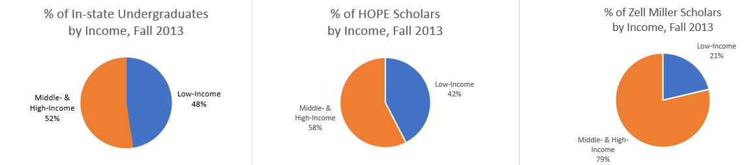
Figure 1. Distribution of Georgia scholarships in 2013 [9].

Lottery Players
Low income populations play the lottery more, but receive scholarships less often than their high-income counterparts. In big jackpot lotteries such as Powerball, participation is generally level across income levels. However, lottery games with comparatively small jackpots drawn on an hourly or daily basis tend to draw players from lower income households [5]. Lottery outlets are often clustered in neighborhoods with large minority populations (especially Hispanic neighborhoods) [11], suggesting significant participation within these groups; yet a study on merit-based scholarships shows there are significant inequities among scholarship recipients. Even in high poverty areas, white students are awarded more non-need, merit scholarships than Black and Hispanic students [7]. From this, we hypothesize that the lottery system redistributes wealth from lower income, minority families to higher income families in the form of scholarships.
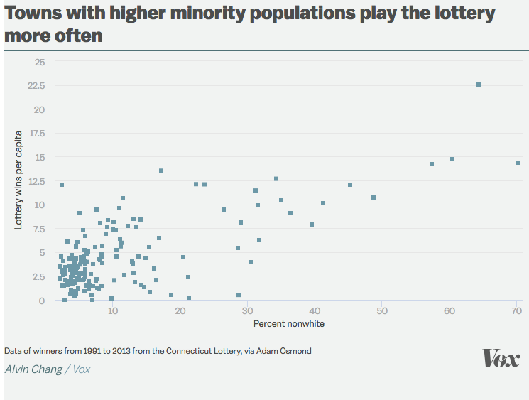

Figure 2. Scatter plot of minority percentages vs. lottery wins from Vox [5] .

Coding Assignment
In this assignment, you will be creating a lottery simulation for Fantasy 5, one of the lottery games in Georgia, to explore and evaluate the lottery’s profitability and effect it has on low income populations.

How it works
A player enters the Fantasy 5 drawing by selecting five numbers from 1 to 42, with no duplicates. The player pays $1 to enter their chosen numbers in a drawing. The lottery draws five numbers at random, and the reward is determined by how many of the player’s numbers match the drawn set. These numbers do not need to match in the same order.

Table 1. Fantasy 5 Rewards
# of matches | ≤1 | 2 | 3 | 4 | 5
Reward | No prize | One free play | $11 | $198 | $212,535
The reward values were based on the average rewards in June 2018 [6].

Deliverables
Complete the functions listed below. Starter code is provided in the file titled LotteryAndWealth.py

def generateLotteryNumbers():
This function should return a list of five random integers between 1 and 42, inclusive. None of the numbers should repeat. This function will be used to generate the list of five numbers entered by the player or drawn by the Fantasy 5 lottery.
To check your work, try writing an if statement or assert statement to determine whether your randomly generated list is the correct length and the contents are within the specified range.

def countMatches(my_list,lottery_list):
This function should take in two lists of equal length representing the player’s chosen number list and the generated lottery list. Return the number of matching integers between both lists.

Example:
my_list | [10, 6, 20, 5, 7] | countMatches will return 3, because both lists contain the numbers 5, 6, and 7.
lottery_list | [30, 6, 7, 40, 5]

def playLottery():
This function should return the reward after playing the lottery once. Assume the lottery costs $1 to enter. Use Table 1 above to determine how much to add to their winnings total. If the player wins a free play, they should be awarded $1. Use generateLotteryNumbers() and numMatches() as helper functions.

When you’ve completed the function, uncomment the following line in the main() function to simulate a person playing the lottery 1,000 times:
simManyPlays(1000)

Run the LotteryAndWealth.py file to observe the result. Try re-running the code multiple times. What general trend do you observe in the graph?

def getDisparityMessage(highIncomeList, lowIncomeList, decade):
This function takes in two lists containing the wealth values for high income and low income groups for a single year and the current decade as an integer, and calculates the percentage of wealth possessed by each group out of total wealth.

Examples:
Table 2. getDisparityMessage() example calculations
highIncomeList | lowIncomeList | Wealth Distribution
[2, 3, 4, 5, 6] | [6, 5, 4, 3, 2] | High income: 50% of wealth  Low income: 50% of wealth
[5, 6, 10, 14] | [1, 5, 7, 2] | High income: 70% of wealth  Low income: 30% of wealth
[4, 10, 2, 5, 8] | [2, 7, 12] | High income: 79% of wealth  Low income: 21% of wealth

The function should return the following string, with L replaced by the current decade and the calculated percentages replacing N and M:

“Decade L: The high income group possesses N% of the community’s wealth, while the low income group possesses M% of the community’s wealth.”

def simLottery(incomeList, numPlayers)
This function should simulate lottery play for a number of players from a given income group. It takes two inputs:
- incomeList: The list containing wealth values for the given income group.
- numPlayers: The number of players from that income group who have entered the lottery this year.

Write code within the loop to simulate lottery play using playLottery(). Pick a random player within the given incomeList and add the reward to their sum of wealth.
Comprehension check: Why is numPlayers used as the bounds for the for loop?

def awardScholarship(incomeList, awardTotal)
This function should redistribute funds from the lottery in the form of a $1 scholarship. It takes two inputs:
- incomeList: The list containing wealth values for the given income group.
- awardTotal: The total amount of lottery funds to be rewarded to members of this income group.

Write code within the loop to distribute the award funds to a random recipient in the given incomeList. Each recipient receives $1 added to their sum of wealth.
Comprehension check: Why is awardTotal used as the bounds for the for loop?

def simCommunity(years, communitySize):
This function should simulate the movement of money between high income and low income communities via the Georgia lottery and scholarship systems over several years. This function has two parameters: years and communitySize. years is the number of years the simulation should be run. communitySize is the number of people in the community.
The simulation can be broken down into 6 tasks:
- Initialize Wealth Lists
- Initialize Record Lists
- Play the Lottery and Distribute Scholarships
- Update Record Lists
- Display Wealth Distribution
- Visualize the Simulation

To get you started, a few variable names and coding patterns have already been coded for you. Fill out the rest of simCommunity() by following the tasks below.

Part 1: Populate Wealth Lists
The starter code contains two lists: highIncomeList and lowIncomeList, which will hold the wealth values for each income group for a given year. Assume half the community is lower income, and half is higher income.

High income group members will begin with 100 as their starting wealth value, and low income group members will start with 99 to represent a small wealth disparity between the two groups. Use Table 3 to begin populating these lists.

Table 3. Community Wealth Lists
List name | Details | Instructions
highIncomeList  (list of ints) | Holds wealth values for the high income group in a single given year. | Assign every element an integer value of 99.
lowIncomeList  (list of ints) | Holds wealth values for the low income group in a single given year. | Assign every element an integer value of 100.

Comprehension check: We can populate these lists with a loop. What are the bounds of the loop, and why?

Part 2: Populate Record Lists
Similarly to Task 1, you should initialize highIncomeRecord and lowIncomeRecord. These will hold a record of all the income lists from every year of the simulation. Use Table 3 to populate these lists.

Table 4. Community Wealth Record Lists
List name | Details | Instructions
highIncomeRecord  (list of lists) | Holds a record of all the highIncomeList lists from every year of the simulation.  (Length = # years in simulation) | Fill with the highIncomeList from year 0. Continue to add to this list after every year of the simulation.
lowIncomeRecord  (list of lists) | Holds a record of all the lowIncomeList lists from every year of the simulation.  (Length = # years in simulation) | Fill with the lowIncomeList from year 0. Continue to add to this list after every year of the simulation.

HINT: Make sure you create a new copy of highIncomeList and lowIncomeList to populate the records because lists in Python are mutable; otherwise, you will keep referencing and updating the same list.
- You can use the copy() function or slicing to do so.

Part 3: Play the Lottery
Inside the simulation loop, use the simLottery() function to simulate community wealth interactions. Since people from lower income neighborhoods tend to gamble more [12], choose 60% of the people from the low income group and 40% of the people from the high income group each year to play the lottery. You will use this as the number of players to pass into simLottery().

Part 4: Award Scholarships
Use the awardScholarship() function to redistribute lottery funds as scholarships. To emulate the disparity in scholarship distribution between income groups, 70% of the funds will be awarded as scholarships to the higher income group, and the remaining 30% will be given to the lower income group.

Part 5: Update Record Lists
Within the simulation loop, update the record lists by appending the current year’s income lists to their respective records.

Comprehension check: We must keep track of which lists we are updating. What list method can we use to prevent accidentally changing the contents of income lists from previous years?

Part 6: Display Wealth Distribution
After every 10 years, use getDisparityMessage() to generate a message describing the overall wealth distribution. Print this message returned by getDisparityMessage().

Part 7: Visualizing the Simulation
To visualize the simulation, uncomment this line of code in simCommunity():
plotSim(highIncomeRecord, lowIncomeRecord)

This code will plot the wealth records of the community over the span of the simulation.

Run the Simulation
In the main() function at the end of the file, comment out:
sim1000Plays()

And finally, uncomment:
simCommunity(80, 30)

This code will run the simulation for 80 years in a community of 30 people total. Run the LotteryAndWealth.py file to see the generated simulation plot. Try running this simulation multiple times with varied time and community size and observe any salient patterns.

Example Outputs
(Note that you will generate slightly different percentages and graphs since the code involves random number generators.)

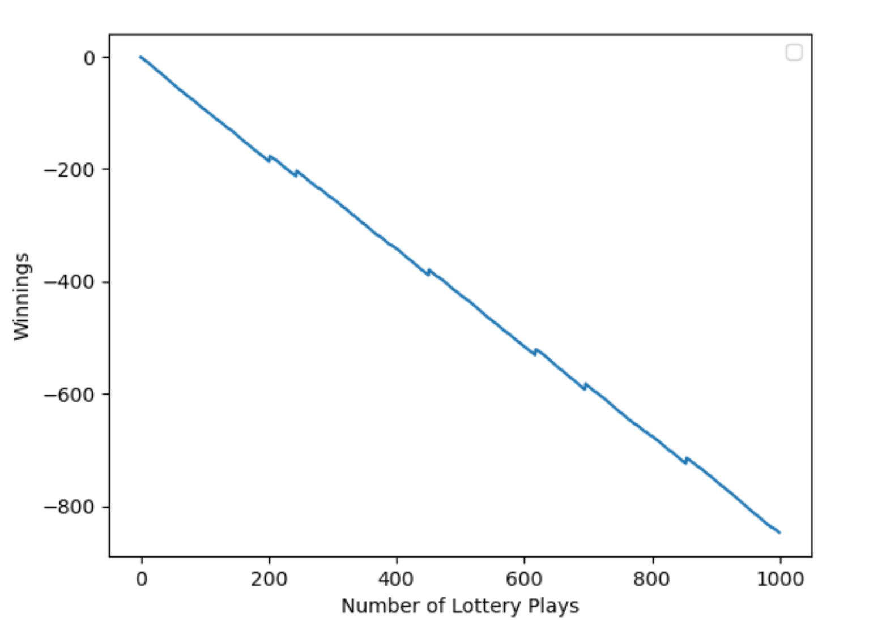
Figure 3. Sample plot after running simManyPlays(1000)

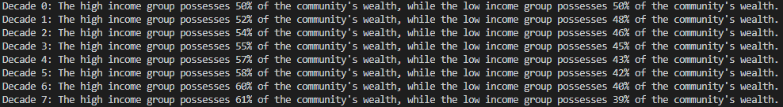
Figure 4. Sample print statements

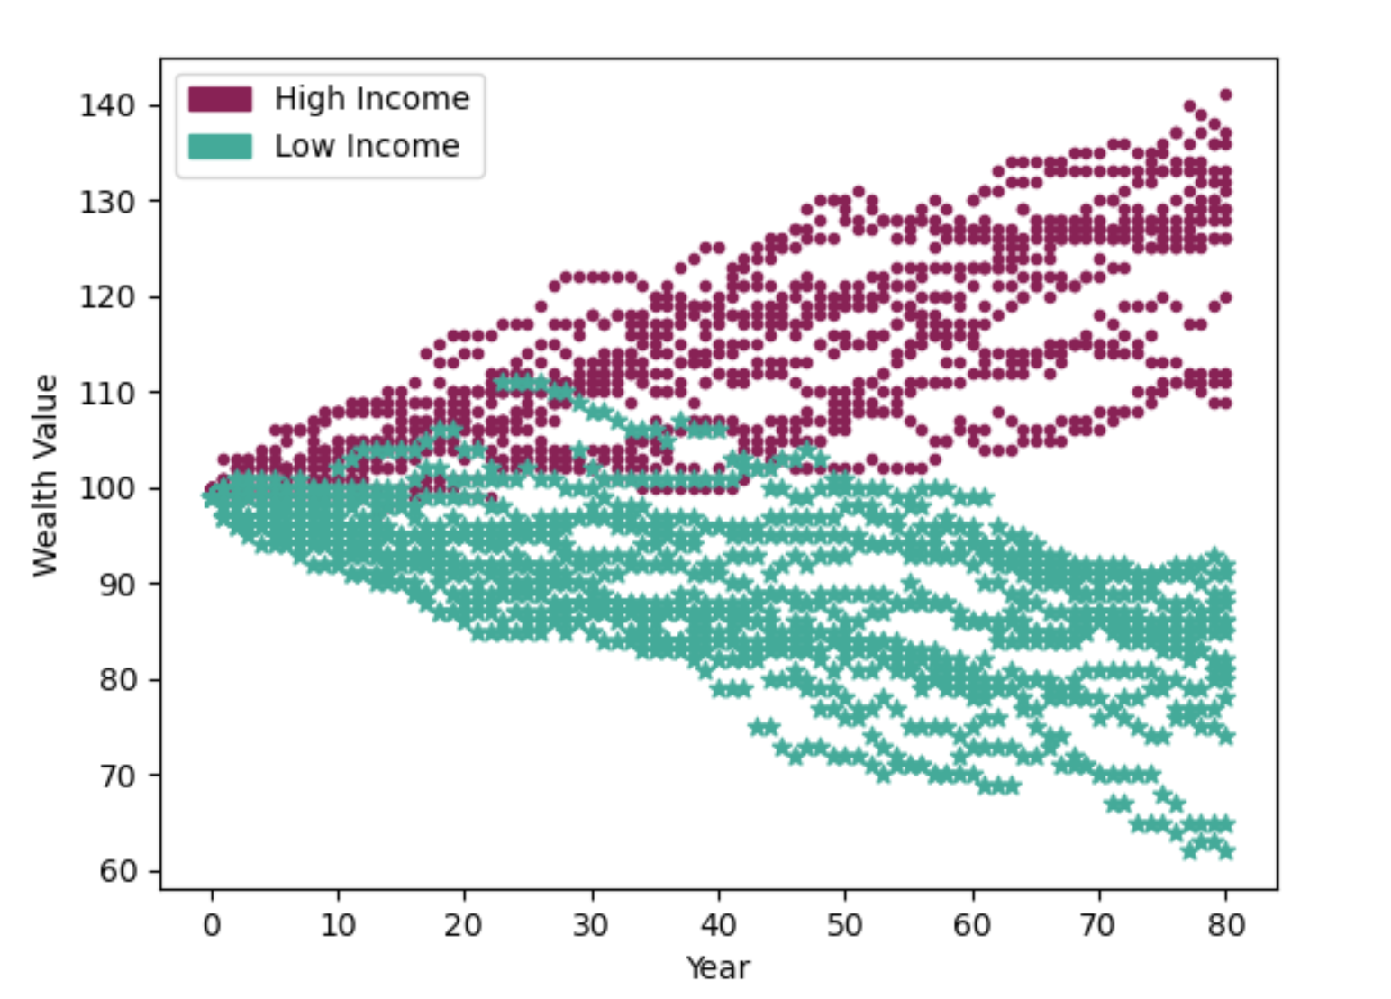
Figure 5. Sample plot of wealth distributions after running simCommunity(80,30).

Follow-up Questions

How much of the wealth does the high income half possess by the end of eight decades? How about the low income half?
Did anything about this assignment surprise you? If so, what?
Occasionally, when running simCommunity(), the scatter plot displays one or more blue and red lines much higher than the rest. What does that line mean?
The lottery and scholarship simulation is only a small factor that contributes to the wealth gap in the United States. Use the internet to find information about how wealth is distributed in your country. For example, how much wealth does the richest 1% of the population have in comparison to the bottom 50%? Use the internet to identify major sources of wealth disparity in your country.
There are many disadvantages to economic inequality, including but not limited to: stifled economic growth, increased crime, decreased health, increased political inequality, and decreased education. Pick one possible negative consequence of economic inequality, research it, and write a short paragraph about how economic inequality might cause that outcome.
Brainstorm one way you could help prevent, reduce, or counter the growing wealth gap.

References

- “About Us.” Georgia Lottery, www.galottery.com/en-us/about-us.html.
- Allman, Justin. “Who Does the Lottery Benefit?”, Wake Forest University, www.radicalmath.org/docs/Lottery_Allman.pdf.
- “Break the Cycle of Poverty.” Stand Together Foundation, 2 Dec. 2020, standtogetherfoundation.org/.
- Caucutt, Elizabeth. “The Real Reason Why Poor Kids Perform Worse in School – and in Life.” The Washington Post, WP Company, 1 Mar. 2019, www.washingtonpost.com/posteverything/wp/2015/04/28/the-real-reason-why-poor-kids-perform-worse-in-school-and-in-life/.
- Chang, Alvin. “4 Ways the Lottery Preys on the Poor.” Vox, Vox, 13 Jan. 2016, www.vox.com/identities/2016/1/13/10763268/lottery-poor-prey.
- “Georgia (GA) Fantasy 5 Prizes and Odds for Sat, Jun 30, 2018.” Lottery Post, www.lotterypost.com/game/41/prizes/2018/6/30.
- Heller, Donald E., and Patricia Marin. "State merit scholarship programs and racial inequality." Civil Rights Project at Harvard University (The) (2004).
- Isaacs, Julia B. “Starting School at a Disadvantage: The School Readiness of Poor Children.” The Social Genome Project, Mar. 2012, www.brookings.edu/wp-content/uploads/2016/06/0319_school_disadvantage_isaacs.pdf.
- Seltzer, Rick. “HOPE for Whom?” Inside Higher Ed, 16 Sept. 2016, www.insidehighered.com/news/2016/09/16/report-finds-georgias-hope-programs-miss-many-students.
- Tba. “Eligibility for the HOPE Scholarship | Georgia Student Finance Commission.” Georgia Student Finance Commission, Georgia Student Finance Commission, www.gafutures.org/hope-state-aid-programs/hope-zell-miller-scholarships/hope-scholarship/eligibility/.
- Wiggins, Lyna, et al. “A Geospatial Statistical Analysis of the Density of Lottery Outlets within Ethnically Concentrated Neighborhoods.” Journal of Community Psychology, vol. 38, no. 4, 6 Apr. 2010, pp. 486–496., doi:https://doi.org/10.1002/jcop.20376.
- Wilde, Cathy. “People in Poor Neighborhoods Are Twice as Likely to Have Gambling Problems, Study Finds.” University at Buffalo, 3 Jan. 2014, www.buffalo.edu/news/releases/2014/01/001.html.

