“Lab 7 - Animating Multiple Elements with Arrays” by Zoë Wood is licensed under CC BY-NC-SA. Accessed from www.engage-csedu.org.

Fall 2015 | CPE 123: Computational Art | Zo¨e Wood

Lab 7 - Animating multiple characters - Tant de Forets style

Goals

The goals for this lab are:

- Practice writing methods
- Practice writing loops
- Practice using an array data structure
- Practice using animation variables
- Practice using arrays

Modality

This is a pair-programming lab - please form teams (or work individually)

Overview

Animating multiple characters can help set a scene. The artists who created the animation Tant de Forets have a style that translate well in Processing (artists: Burcu Sankur and Geoffrey Godet). Please watch the short film - you can find it online and mimic one of the scenes creatures and settings. Be sure your scene includes at least 5 versions of the animating character.

Details
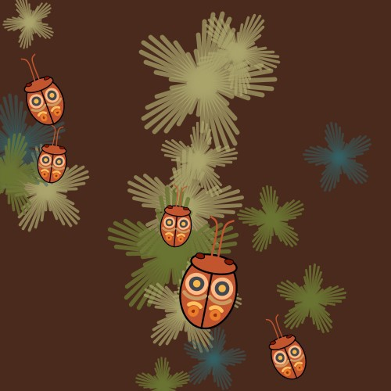
Figure 1. Five bugs (inspired by Tant de Forets) .
Tasks: This lab is to create an animation with multiple creatures moving across the screen each with a slightly different starting position and different pace (or velocity). Your program must use arrays to control the animation of the creatures.
Your ‘sketch’ of the scene must:

- Include at least 5 different creatures which head in at least 5 different directions.
- Include some difference in appearance from one another (color or scale). You can use the creature you designed in an earlier lab, or one of the parametric shapes you designed or something new.
- Use arrays to represent the positions of the creatures (x and y) and the velocity the creatures are traveling (vx and vy).
- Use a function to draw one creature that uses function parameters to control the appearance of the creature (scale, rotation and location).
- Include an update function that updates the position of each creature.
- Include a loop that draws and updates the position of the creatures per frame.
- Include a simple animation (moving position (and optionally size or color)) of at least 5 creatures.
- All creatures must start in a reasonable position and travel in a reasonable direction.
- Several background elements (repeated) that are static positioned using arrays.

Please play with your animation and consider modifying the colors and scale of creatures to make a compelling looking sketch. Also consider playing with your background to set the scene for your animation.

Demo:

In order to receive credit for this lab, you must demo your sketch to your instructor or TA. For every lab, your score will be broken down 75% for meeting the technical requirements and 25% for aesthetics.

Submitting your sketch

You must post an image of your sketch to your Pinterest Computational Art board. Also pin the frame from Tant de Forets that you used as your reference images to your Pinterest board as well.

Resources:

https://youtu.be/IsiGjj0ljEE http://burcusankur.com/ http://geoffreygodet.com/index.php

/*cpe 123 - fall 2015 - example of arrays for animation - ZJ Wood */ float px[];
float py[]; float vx[]; float vy[]; color ballC[]; int numBalls;

void setup() { size(400, 400);
numBalls = 5;
px = new float[numBalls]; py = new float[numBalls]; vx = new float[numBalls]; vy = new float[numBalls];
ballC = new color[numBalls];
for (int i=0; i <numBalls; i++) { px[i] = random(20, 380);
py[i] = random(300, 400); vx[i] = random(-0.5, 0.5);
vy[i] = random(-1, -3);
ballC[i] = color(random(0, 255), random(0, 255), random(0, 255));
}
}

void draw() { background(12, 34, 56);
for (int i=0; i < numBalls; i++) {
//draw the ball fill(ballC[i]);
ellipse(px[i], py[i], 30, 30);

//update position based on velocity px[i] += vx[i];
py[i] += vy[i];
}
}

