Project: Console Game Application
Sandra H. Jones, Kennesaw State University

Objectives
This assessment is to allow you to demonstrate your understanding and abilities with regard to all of the fundamental programming concepts that we have covered this semester [Objectives 1-6]. Suggestions for increasing the complexity of the project are shown at the bottom of these instructions.
- Data Types and Variables
- Input/Output
- Conditional Expressions
- Classes
- Looping
- Methods
- Arrays
- Random Class
The object of the game that you will create is to capture as many monsters in as few guesses as possible. Follow the instructions listed below:
Classes
- Start with a blank console application.
- Add a class named “Monster” that has the following attributes: string name. Feel free to make your monster have other attributes, but they are not required.
- Create a constructor that accepts the name via parameters to create a new monster.
- Create a property for the name field and use it to access the field.
- Create one method named captureMessage() that returns the following string “The mighty [name] has been captured!”
Arrays and Randomness
- Create an empty 1D array that is 13 slots big. Randomly place 3 monsters in the 1D array. These will be hidden to your player. NOTE: You may want to place the monsters manually for yourself during testing and coding! The remainder of the positions should be empty.
- Create a parallel array of strings to handle the display for your player. At the beginning of the game, your interface should look something like the one shown below.

- 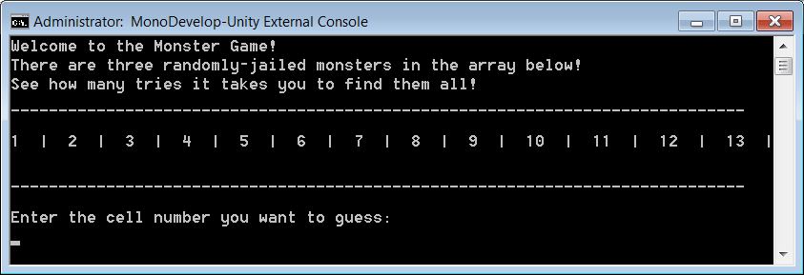
- Create an empty 1D array of strings that will hold the three monsters that the player will capture. When a monster is caught, store the name of the monster, concatenated with the string returned by the captureMessage() method in this array.
Methods, Input/Output, Loops, Conditional Expressions
- Write a method that outputs to the console the array you created in step #7. This will simulate the state of the monster jail.
- Write a method that asks the player to select a cell using the numbering from your display. Determine if there is monster in that cell or not, and give your player appropriate feedback. This method should be called repeatedly from main until the game is done. If the player selects a square that doesn't contain a monster, give feedback to your player - "hot" means there is a monster in an adjacent cell, "cold" means there is not. If the player selects a square that contains a monster, that monster is considered captured and should be moved to the 1D array that represents the monster jail. Be mindful of the bounds of the array when you do this!
- Give your player feedback in the grid output so that they know when a square has already been chosen. You should also write the code to not allow a player to select a number more than once.
- Following each guess, give your player feedback regarding captured monsters. You can use your array from step #8 to handle this. Do this in list format in the console. A sample screen shot of a game in progress is shown below.
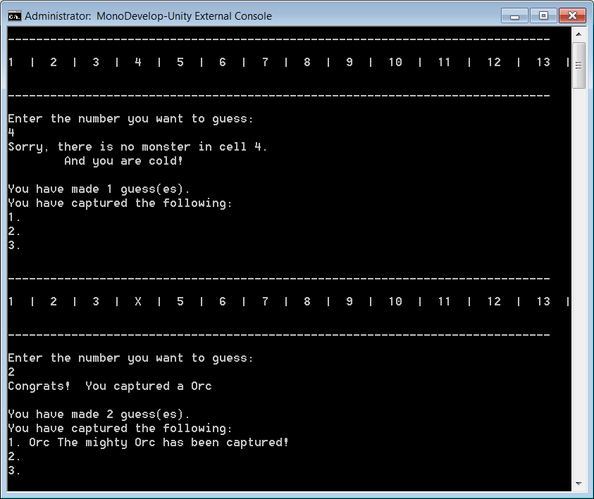
- Create a mechanism that tracks how many guesses it took to capture all of the monsters. If you’d like, make your game so that a player has a limited number of guesses.
- Game is over when all three monsters are collected. Shown below is what the interface might look like at the end of the game.
