Authors
6 student authors. Names withheld for privacy.

Everyday Object Example
(Fall 2012, The Super Optimistic Noodle Squad)

OBJECT: Pair of Nail Clippers

- the mechanical function of your object.
- what need is fulfilled by this object.
- the physical attributes and characteristics of your object.

DESCRIPTION:

Nail clippers are a small, metal object with two curved blades that close together, and are used to trim fingernails or toenails. Typical dimensions are 1.75 or more inches (4.5 or more cm) in length, .375 to .5 inches (.9 cm to 1.2 cm) in width and .375 to .5 inches (.9 cm to 1.2 cm) in height (when compressed). It has two sharpened, curved pieces of metal that are used to cut nails by pressing together, closing down on the top and bottom of a nail. It helps people maintain good hygiene by keeping nails a proper length. It cuts nails by closing in from the front rather than from one side, as scissors do. Its design makes it fairly easy to apply enough force to cut through fingernails or toenails.

Physical attributes and mechanical function: Three rectangles of metal (often stainless), each of dimensions of 1.75-2 in. (4.5-5 cm) long by .375 to .5 in. (1-1.3 cm) width by 1/16 in. (1.5 mm) high make up the main structure. Two of the rectangles are joined one end, and are shaped with sharpened curves facing each other at the other end, so that when the two joined rectangles are not being pressed together, the sharpened ends are slightly separated. The third rectangle, the lever, is joined to the other two by a small bolt, which passes through the two joined pieces via a hole near the sharpened ends. The lever is joined to the small bolt in such a way that it can pivot, folding for compact storage, and it has a small wedge just behind where it is joined to the small bolt. When the lever is pressed, it gets closer to the two connected pieces and the small wedge forces the two connected rectangles to close their sharpened ends together. A sample is pictured below. The user’s hand provides a force on the third rectangle and on the other sides with the two connected pieces. This results in the cutting of whatever is between the sharpened ends.

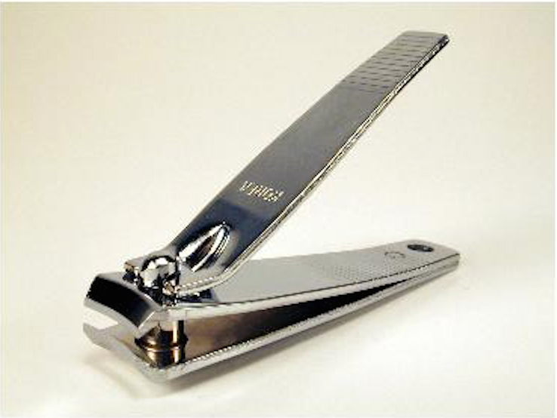

Mechanical function: As mentioned earlier, nail clippers apply a lot of forces due to their design. This is because nail clippers utilize a mechanical pivot point that is very close to the curved blade (this pivot point is the small wedge on the bottom of the third (top) rectangle), while the edge of their handles are very far from the point of pivot. (The pivot point is also known as the fulcrum). The third metal piece with its wedge act as a class 2 lever, allowing for a small input force from the user to cut through the tough nail. If one were to try to using a nail clipper by applying force very near to the fulcrum, one would notice that it is harder to cut nails when pressing on the top rectangle near its fulcrum than when pressing on the top rectangle on the end that is farthest from the fulcrum (pivot point). This is because of a mechanic principle: the moment of a force at a point can be increased by increasing the distance from the pivot point. A greater moment makes it easier to push a lever down, thus making fingernails easier to cut. Using the principles of mechanics to its advantage is one of the characteristics that make nail clippers so efficient.

Needs fulfilled by object: Nail clippers have several features that make them well suited for trimming protruding objects, aka nails and or dead skin that is jutting out. Unlike a scissor, nail clippers have very narrow slots between their blades, which can be a safety feature because the blades do not have as much chance to slash someone like a knife blade. Having blades that are curved and able to be clamped down slowly lets the user see in advance the part that they want to clip off and make adjustments before clamping down if they think it would be clipping off too much. This makes nail clippers better suited for clipping small object with better detail than a scissors or knife. The design of nail clippers also allows them to cut across it sharp edge at a uniform time. With scissors or a knife there will be a delay between the beginning and the ending of a cut, which could lead to an inaccurate cut, whereas nail clippers cut at the same time allowing for uniformity. Another feature of nail clippers I that some have small compartments to catch loose nails that fall off after they are clipped, making nail clippers a handy too for clipping nails indeed. Additionally, nail clippers are not just for cutting nails. They can be used to cut any number of small objects, such as sales tags on clothes, loose threads on clothing, string around packages, and etc.

Analysis [10 points]

Analysis 1 [5 points]. Consider your object as a computer program. Draw a diagram that shows all its functions as boxes (name them), and for each function, its inputs and outputs. Are there shared inputs and outputs among the functions? Discuss.

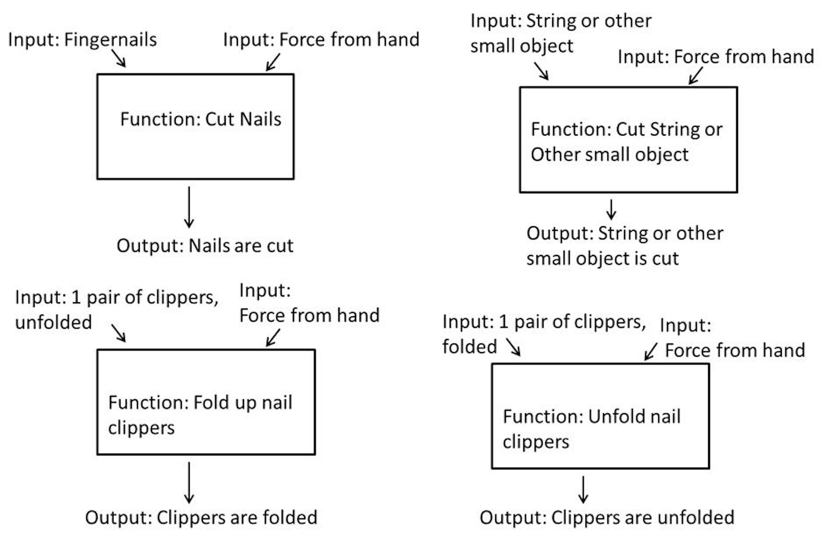
Figure 2. A diagram showing all of the functions of fingernail clippers as boxes with inputs going into each box and outputs coming out.

In Figure 2, several functions of fingernail clippers are represented as boxes. Inputs to the functions performed by the fingernail clippers are shown going into the boxes, and outputs of the functions are shown as arrows coming out of the boxes. Two of the functions, “Cut fingernails” and “Cut string and other small objects”, are close related. The inputs are similar: one requires fingernails, a small object, and the other requires string, another small object. They both require the same cutting force input by the hand, and both result in the small object being cut. The third function, “folding fingernail clippers”, requires force input by the hand to fold, but it is not a “squeezing” force but a more complicated motion. The result is that the clippers are folded, so this function changes the state of the clippers. There is also a reverse of this function, which has folded clippers and a force by the hand as an input, and unfolded clippers as the output.

Analysis 2 [5 points]. Consider the list of physical attributes and characteristics. Organize these such that each is declared as a variable with its proper type. Can some of these attributes/characteristics be arranged into a hierarchy of related attributes/characteristics? Discuss.

Variable description Name (Class)

top blade: tblade (blade)
bottom blade: bblade (blade)
top metal piece: tmetal (metal rectangle)
bottom metal piece: bmetal (metal rectangle)
pin: pin (metal cylinder)
wedge: wedge (metal triangle)
lever: lever (metal triangle)

(The lever is the metal rectangle that folds and can be pressed down on to cut; it is connected to the top and bottom metal pieces by the pin.)

tblade and tmetal are related in that the first is connected to the second. Same with bblade and bmetal, and with wedge and lever. tmetal and bmetal are connected at one end, and join together at the other end when the lever is pressed on by the hand. Pin ties them all together.

We can organize the pieces into three categories: top, bottom and connector/functionality. Top contains objects that are located in the top portion of our device, such as tblade and tmetal. Likewise, bottom describes pieces in the bottom section of our device; namely bblade and bmetal. The other pieces, pin, wedge, and lever, can be lumped together in connector/functionality because they all serve as ways to hold the system together, as well as, allow it to function properly.

Reflection [10 points]

Reflection 1 [5 points]. Consider your response to Analysis 1, are there functions can be combined so that the object can be represented with a more concise program? Are there new functions that should be introduced to better describe your object such that the functions are more modular? Discuss.

The functions for cutting string and fingernails could be split so there is one main cutting function, and different functions modeled off of this function with different inputs to cut.

Since a nail is somewhat of a small object, combine the inputs of the two functions “Cut small objects” and “Cut nails” and produce the combined function “Cut small objects”, which can have an input of either “fingernails” or “small object” and an output of “small objects or nails are cut”.

Reflection 2 [5 points]. Have you heard of abstraction? How does abstraction in computer science relate to the process of identifying the functions and characteristics as you have done in this exercise? Discuss.

We used abstraction to figure out what was necessary to the design of this product. We could have had more specific descriptions of the shapes of different components, but that wouldn’t have changed the nature and function of the product. We defined the long metal pieces as separate from the blades, though physically they are one piece, to better describe the action of the clippers.

For a formalized report we would have given a detailed description of each component. For example, we could have had a section for only the top blade describing its geometry, i.e. the gradient and sharpness of the blade, how it is connect to and/or interacts with other pieces of the device. Once each object is outline and their interactions are made clear the reader can gauge an accurate response to the workings and purpose of the device.

We tried to be very specific about how each of the components are connected, so that the reader can tell how the device functions. The more details we provide, and the more clearly we describe the objects, the less chance that the reader will be confused. If someone was to make this object based on our description, the more accurate the description the better.

Citations
Do we have to anything else for this project

Discussion

Student A’s object (3 comments) – Student A
I think scissors, nail clippers, or clothespins are good choices
Posted: 12:23:01 PM 10/01/2012

Student A’s object (1 comment) – Student B
I’m up for anything. Nail clippers sound good to me. I don’t want to do scissors now, only because we talked about them in class.
Posted: 9:05:32 PM 10/02/2012

Student A’s object (1 comment) – Student C
Hey guys sorry I just started getting on this. Chris showed me how to get on but for some reason my laptop still will not allow me to log in. I don’t know what the problem is. I’ll go with just about anything but also think that we shouldn’t go with scissors because we talked about them in class. So I’m fine with nail clippers to.
Posted: 4:43:41 PM 10/04/2012

(1 comment) – Student D
Personally, I’m in favor of scissors, though it doesn’t really matter to me.
Posted: 3:21:43 PM 10/02/2012

(1 comment) – Student D
Ok, so unless anyone objects let’s plan on going with clippers. I am going to go ahead and assume if nothing else is decided on by Thursday night/Friday morning we will do clippers.
Posted: 11:30:30 PM 10/03/2012

Nail Clippers (1 comment) – Student A
Ok, I started the description for nail clippers, as everyone seems ok with that. Please feel free to edit. Thanks.
Posted: 8:59:03 PM 10/04/2012

Safety/extra features (2 comments) – Student E
Hey guys, since most of the descriptive part has been done, I think I might just add extra/safety features of nail clippers.
Posted: 3:12:17 PM 10/07/2012

Safety/extra features (1 comment) – Student E
I’ll also elaborate a bit more about the mechanical property of nail clippers.
Posted: 3:32:59 PM 10/07/2012

using tab (1 comment) – Student B
I was having the same problem. The website will not allow the use of ‘tab’ to indent paragraphs. For me it would just cycle through submit and cancel. It’s not a big deal. I just made sure that all the paragraphs were spaced with 5 spaces at the beginning.
Posted: 7:03:56 PM 10/07/2012

what else (2 comments) – Student C
do we have to comment on anything else for this project?
Posted: 6:22:14 PM 10/10/2012

what else (1 comment) – Student C
ive been having a lot of problems with this page and can only get on every now and then so I am just wondering what else we have to do so I can get it done now.
Posted: 6:23:23 PM 10/10/2012

Anything else to do (1 comment) – Student E
If anyone has any idea on what to do next, they should tell the team. From what I gathered it seems like we need to do more than just describe the item and functions. We need to draw some sort of diagram with functions as boxes and assign variables and names to them. Then we need to make them into programs or functions that are modular. Lastly is talk about something called abstraction and how it relates to this exercise.
Posted: 3:25:04 PM 10/14/2012

(1 comment) – Student A
I think that we’ve got to do now is answer the two Analysis quests and two Reflection questions under “Week 2” of the handout for this lab. As I read it, we just put answers underneath our description of the Nail Clippers, and everyone must contribute something to the answers.
Posted: 9:27:00 10/14/2012

(1 comment) – Student D
I don’t know how to do the flow charts on this page, but I think we should add a function to fold the clippers in/out.
Posted: 11:40:46 AM 10/15/2012

(2 comments) – Student A
Ok I will add a function to fold clippers in and out. I just made the drawing on Powerpoint and pasted it in.
Posted: 9:14:18 PM 10/15/2012

(1 comment) – Student C
wow guys this looks really good
Posted: 10:20:21 AM 10/16/2012

