**Intro to Computer Science**

**PA03**

**Working with Iteration**

**Code due by Wednesday, Feb 12th at 11:00 AM**

**Paperwork due the same day at the start of class**

**Customer Request #1 (money.py)**

You are contacted by Dr. Markmy Cash who teaches finance at Whatsamatta U.  He wants to be able to show students the effects of compound interest.

A bank account, for example, may have its interest compounded every year: in this case, an account with $1000 initial principal and 20% interest per year would have a balance of $1200 at the end of the first year, $1440 at the end of the second year, and so on. He asks you to write a program that:

* prompts the user for an amount of money to invest in the compounding account
* prompts the user for the interest rate per year
* prompts the user the number of years to compound
* displays the balance of the account for each year

For example:

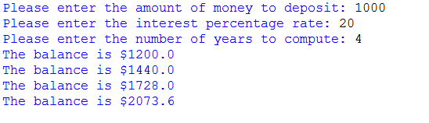

Hint: Don't worry about rounding off long floating point numbers right now.

**Customer Request #2 (numbercounter.py)**

Dr. Matic returns he wants a program to compute the number of times a given digit *D* appears in a given number *N*.   For example,

* The number of times 5 appears in 65505 is 3.
* The number of times 6 appears in 65505 is 1.
* The number of times 7 appears in 65505 is 0.

Your task is to implement the following the algorithm.

1. Ask the user for the value of N, a positive integer (the larger number)
2. Ask the user for the value of D, a positive integer (the single digit)
3. Initialize a counter to 0
4. Decompose the number *N* into its quotient and remainder when dividing by 10 (Review the material in section 1.7.1 in your textbook)
5. Increment the counter if the remainder is the digit *D*
6. Repeat steps 4 and 5 as long as there are digits left to process

Example:

|  |  |  |  |
| --- | --- | --- | --- |
|  | quotient | remainder | counter |
| Start - 65505 |  |  | 0 |
| Pass One starts with 65505 | 6550 | 5 | 1 |
| Pass Two starts with 6550 | 655 | 0 | 1 |
| Pass Three starts with 655 | 65 | 5 | 2 |
| Pass Four starts with 65 | 6 | 5 | 3 |
| Pass Five starts with 6 | 0 | 6 | 3 |
| End because there is nothing left to consider |  |  | 3 |

**Additional things to consider**

1. This should be done using mathematical operations and not any technique which chops up the input as a string (that will come later in the semester.
2. The program should have error checking to make sure the user inputs are valid. I can think of two potential errors:
   * If a user gives non-integer inputs (see the hint below)
   * If a user gives more than a single digit for D

In either case, notify the user that the input(s) are incorrect and prompt again.

**Helpful hint**

To check if a string provided to an input function consists of digits only, you can use the “isdigit” method of the “str” type.  Test out this method by assigning different string values to a variable, say “A”, and then calling the “isdigit” method on this variable, as in “A.isdigit()”.  Type “help(str.isdigit)” to find more information.

**Sample Output**

Notice that  the following tests most of the "wrong" input.  It also shows some sample output for correct input.

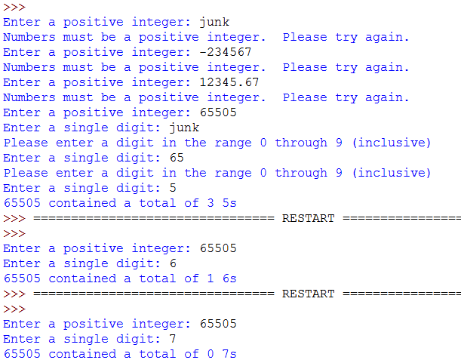

**Final Submission**

To upload your homework for grading, log on to eLearning, select this class, and navigate to the "Assignment Submissions" area. Click on the "Programming Assignment 3" folder and upload both python files in their designated locations.

In addition to this, you should print paper copies of your code and design document. Please submit these stapled printouts in the following order in class the day the assignment is due:

* design document
* money.py
* numbercounter.py